RETAIL SALES ANALYTICS SYSTEM
A PROJECT REPORT
Submitted by
KARMAN SINGH CHAWLA, UID: 25MCI10399
ANMOL KUMAR, UID: 25MCI10386
in partial fulfillment for the award of the degree of
MASTER OF COMPUTER APPLICATIONS
IN
COMPUTER APPLICATIONS

UNIVERSITY INSTITUTE OF COMPUTING
CHANDIGARH UNIVERSITY, GHARUAN, MOHALI, PUNJAB
OCTOBER 2026

BONAFIDE CERTIFICATE
Certified that this project report “Retail Sales Analytics System” is the bonafide work of “______________________________” who carried out the project work under my/our supervision.
HEAD OF THE DEPARTMENT  DR.AMANPREET KAUR SANDHU  SIGNATURE | SUPERVISOR  MR. ANAND PANDEY  SIGNATURE

Submitted for the project viva-voce examination held on ____________________
INTERNAL EXAMINER | EXTERNAL EXAMINER

ACKNOWLEDGEMENT
I would like to thank my project supervisor and the Head of the Department for their guidance, and my teachers and reviewers for the feedback they gave while the project was taking shape. I am also grateful to the maintainers of Python, Flask, MySQL, PyMySQL, Chart.js and openpyxl, whose free tools made this work possible, and to my family and friends for their steady support throughout.
ABSTRACT
Every shop collects sales records, but turning those records into answers is harder than it sounds. Revenue, order counts and category trends usually end up spread across spreadsheets that were filtered in slightly different ways, and nobody is quite sure which number is the right one.
Retail Sales Analytics is a small system built to fix that. It stores customers, products, orders and order lines in a normalised MySQL database, serves them through a Flask REST API, and shows them in a browser dashboard with Excel export. The dashboard gives revenue, order count, units sold and average order value, draws monthly and category charts, and lets the user filter by text, date range and any number of categories. Separate forms record new sales, customers and products. When a sale is saved, the API checks the input, reads the price from the product table instead of trusting the browser, and writes the order header and its item inside one transaction. The project uses Python, Flask, PyMySQL, Chart.js and openpyxl.
The report analyses a CSV snapshot of 69 order lines covering 37 orders, 201 units and INR 159,188.00 in revenue. Electronics earns the most among the categories and October 2026 is the strongest month. The earlier project report records 15 of 15 end-to-end checks passing on clean seed data, and the headline figures here were recomputed independently from the CSV. The system is a single-store, single-user sample: sign-in, multi-item orders and edit or cancel screens are left for future work.
Keywords: Retail analytics, MySQL, Flask, REST API, dashboard, Excel, sales reporting.
GRAPHICAL ABSTRACT
The figure below shows the overall workflow of the Retail Sales Analytics System, from recording a sale to sharing a filtered export.
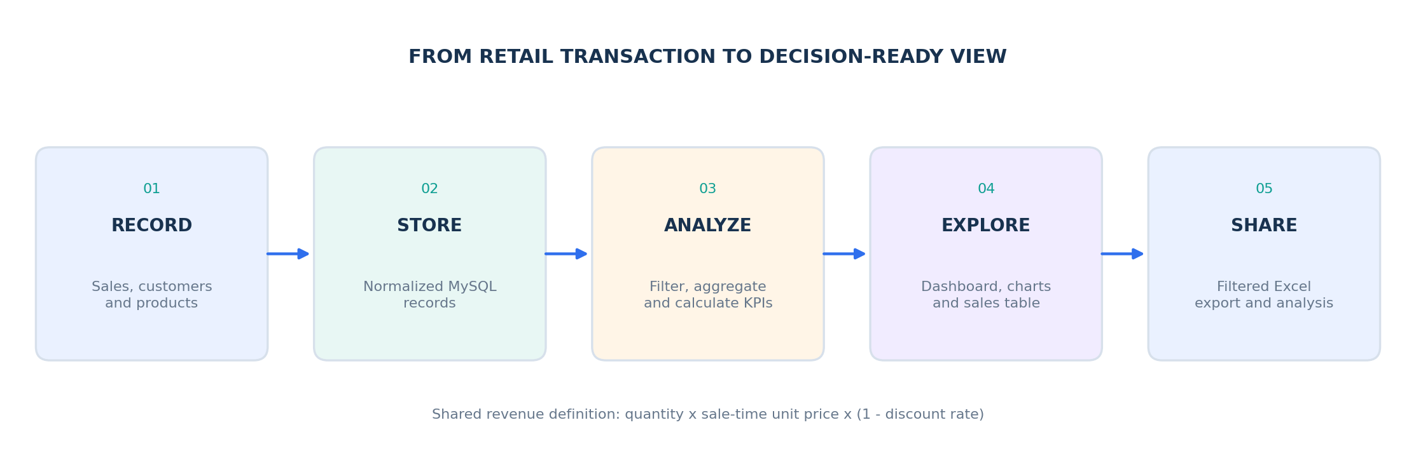
Figure 0.1: Workflow of Retail Sales Analytics (record, store, analyse, explore and share)

TABLE OF CONTENTS
BONAFIDE CERTIFICATE i
DECLARATION i
ACKNOWLEDGEMENT ii
ABSTRACT ii
GRAPHICAL ABSTRACT ii
TABLE OF CONTENTS iii
LIST OF FIGURES iv
LIST OF TABLES iv
ABBREVIATIONS v
SYMBOLS v
CHAPTER 1. INTRODUCTION 1
1.1 Identification of Client / Need / Relevant Contemporary Issue 1
1.2 Identification of Problem 1
1.3 Identification of Tasks 1
1.4 Scope and Users 1
1.5 Significance of the Work 1
1.6 Organization of the Report 2
CHAPTER 2. BACKGROUND STUDY AND REQUIREMENTS 2
2.1 How Retail Reporting Is Usually Done 2
2.2 Review Summary 2
2.3 Problem Definition 2
2.4 System Requirements 2
2.5 Technology Selection 3
2.6 Logical Architecture 3
2.7 Assumptions and Constraints 3
CHAPTER 3. DESIGN FLOW / PROCESS 3
3.1 Relational Data Model 3
3.2 Integrity and Revenue Logic 4
3.3 Request and Transaction Workflow 4
3.4 Shared Filters 4
3.5 Data Processing 5
3.6 Design Decisions and Alternatives 5
3.7 Module Overview 5
CHAPTER 4. RESULTS ANALYSIS AND VALIDATION 5
4.1 Dataset Snapshot 5
4.2 Category Performance 5
4.3 Monthly Performance 6
4.4 Payment Mix and Outlier Context 6
4.5 Filtered View Example 6
4.6 Requirement-wise Verification 7
4.7 Verification Record 7
CHAPTER 5. CONCLUSION AND FUTURE WORK 7
5.1 Conclusion 7
5.2 What the Project Taught 7
5.3 Limitations 7
5.4 Future Work 7
REFERENCES 8
APPENDIX 8
A. Principal Project Files 8
B. Project Screenshots 8
USER MANUAL 9
PROJECT REPOSITORY 10

LIST OF FIGURES
Figure 0.1: Workflow of Retail Sales Analytics (record, store, analyse, explore and share) ii
Figure 2.1: Application layers and the reporting path 3
Figure 3.1: Core entity relationships and key fields (normalised order and line-item model) 4
Figure 4.1: Dashboard KPI overview 6
Figure 4.2: Revenue by category 6
Figure 4.3: Monthly revenue trend 6
Figure 4.4: Revenue by payment method 6
Figure B.1: Full dashboard: revenue, orders, units, average order value, charts and sales table 9
Figure B.2: Entry forms for a sale, customer and product; the sale price comes from the product record 9
Figure B.3: Browser Downloads confirms the generated sales_export Excel workbook 9
Figure B.4: Filtered example with Clothing and Groceries selected; its KPIs and 28 displayed lines are specific to that filter 9
Figure C.1: GitHub repository “retail-sales-analytics” with the backend, data, database, docs and frontend folders and the project README 11
LIST OF TABLES
Table 2.1: System requirements and the evidence for each 2
Table 2.2: Technology stack and the reason for each choice 3
Table 3.1: Main tables and their key fields 4
Table 3.2: Design decisions and the alternatives considered 5
Table 4.1: Dataset snapshot 5
Table 4.2: Payment method mix 6
Table 4.3: Requirement-wise verification 7
Table 4.4: Verification evidence and status 7
Table A.1: Principal project files and what they do 8
Table M.1: Common problems and what to try 10

ABBREVIATIONS
Abbreviation | Full Form
API | Application Programming Interface
AOV | Average Order Value
CSS | Cascading Style Sheets
CSV | Comma-Separated Values
DBMS | Database Management System
ERD | Entity-Relationship Diagram
FK | Foreign Key
FR | Functional Requirement
HTML | HyperText Markup Language
HTTP | HyperText Transfer Protocol
INR | Indian Rupee
JSON | JavaScript Object Notation
KPI | Key Performance Indicator
NFR | Non-Functional Requirement
PK | Primary Key
REST | Representational State Transfer
SQL | Structured Query Language
UI | User Interface
UPI | Unified Payments Interface
XLSX | Excel Open XML Spreadsheet
SYMBOLS
Symbol | Meaning
→ | Flow direction / data flow between stages
× | Multiplication (for example quantity × unit price)
÷ | Division (for example total revenue ÷ distinct orders)
% | Percentage (discount rate on the sale form, share of total revenue)
1 : many | One-to-many relationship between two tables
Revenue | quantity × sale-time unit price × (1 − discount rate)
AOV | Total revenue ÷ number of distinct orders

CHAPTER 1. INTRODUCTION

1.1 Identification of Client / Need / Relevant Contemporary Issue
Every shop, big or small, ends up with a pile of sales records. The records themselves are not the problem. The trouble starts when someone asks a simple question, such as which category earned the most this quarter or how October compares with September, and the answer has to be pieced together from several spreadsheets that were each filtered a little differently. A small retailer rarely has time for that, and a student building a reporting project runs into the same wall very quickly.
The clients for this project are small retail operators, analysts and students who want to see how database-backed reporting works from start to finish. They do not need a large enterprise suite. They need something that runs on an ordinary Windows laptop, keeps its data in a proper relational database, shows revenue, orders, units and average order value at a glance, and lets them export exactly the rows they are looking at.
The Retail Sales Analytics System is built around that need. MySQL keeps the customer, product, order and order-line records. A Flask API sits between the database and the browser, checks every input and handles the transactions. The dashboard shows the summary cards, charts, filters and entry forms, and the Excel export carries the same filtered selection into a spreadsheet for deeper offline analysis.

1.2 Identification of Problem
The central problem is fragmented retail reporting. Operational data, summary figures and spreadsheet analysis drift apart because each one is prepared separately. In everyday practice this shows up in a few familiar ways:
- The numbers on screen, the table below them and the exported file are often produced with different filters, so they stop agreeing with each other.
- “Revenue” means different things to different people. Some include the discount and some do not, and a later price change can quietly rewrite old sales if the price was never stored with the order.
- Searching across customers and products, or narrowing things down to one date range and a few categories, is slow when it is all done by hand.
- Typing a price by hand while recording a sale invites mistakes, because whoever enters the data can type any number they like.
This project answers those points with a filter-aware dashboard, one shared revenue definition and a server-side transaction workflow, so that the rows, the metrics and the export always describe the same selection of data.

1.3 Identification of Tasks
- Work out what the dashboard has to answer: KPIs, trends, filters and exports.
- Design a relational database that keeps sales history and referential integrity.
- Build Flask API endpoints for sales, master data, summaries, charts and Excel export.
- Build a filter-aware dashboard whose KPIs, charts, table and export share the active selection.
- Validate sale inputs and take prices from the product catalogue on the server.
- Analyse the CSV dataset and recompute the headline metrics independently.
- Verify the data path end to end and record the evidence honestly.
- Document the setup, limitations and future work, and prepare this report.

1.4 Scope and Users
The intended users are a small retail operator, an analyst or a student demonstrating database-backed reporting. The included sample covers one store with a limited set of customers, products and transactions. The system supports one product line per sale-form submission. It does not provide sign-in, role management, multi-store inventory or edit and delete screens, and the report treats those as clear boundaries rather than hidden gaps.

1.5 Significance of the Work
For a small shop, the main benefit is trust in the numbers: the same revenue formula and the same filters sit behind every card, chart, table row and exported cell. For a learner, the project shows how a relational schema, a validated API, a browser front end and a spreadsheet export fit together in one small, readable codebase. For anyone planning to grow the system later, it provides a clean base on which authentication, inventory and multi-item orders can be added without redesigning the data model.

1.6 Organization of the Report
- Chapter 2 – Background Study and Requirements: how reporting is usually handled, the problem definition, requirements, technology and architecture.
- Chapter 3 – Design Flow / Process: the data model, integrity rules, revenue logic, transaction workflow and design decisions.
- Chapter 4 – Results Analysis and Validation: dataset results, category, monthly and payment analysis, and the verification record.
- Chapter 5 – Conclusion and Future Work, followed by References, Appendix, User Manual and the Project Repository.

CHAPTER 2. BACKGROUND STUDY AND REQUIREMENTS

2.1 How Retail Reporting Is Usually Done
Before settling on a design, it helps to look at the ways small retailers normally deal with their sales data. Each has real strengths, and each leaves a gap that this project tries to fill.
- Plain spreadsheets: easy to start and familiar to everyone, but formulas, filters and copies multiply over time and it becomes hard to say which file holds the correct total.
- Built-in reports of billing or point-of-sale software: convenient and always up to date, but usually fixed in shape, so a custom date range with a chosen group of categories may not be possible.
- Cloud dashboards and business-intelligence tools: powerful and polished, but often paid, dependent on an internet connection and more than a small shop or a student project needs.
- Hand-written SQL queries and scripts: flexible and exact, but they need technical skill every time and give a non-technical user no screen to work with.

2.2 Review Summary
Taken together, these options show a clear gap. What is missing is a small, local application that keeps data in a real database, shows the key figures and charts in a browser, lets the user filter in a natural way, and exports the filtered rows to Excel without changing the definition of any number on the way. The Retail Sales Analytics System is designed to sit in exactly that gap.

2.3 Problem Definition
The task is to design and build a web-based retail analytics application that:
- Stores customers, products, orders and order lines in a normalised MySQL database with proper constraints.
- Shows revenue, orders, units sold and average order value together with monthly and category charts.
- Lets the user search by text, filter by date range and tick any number of categories, with every view following the same selection.
- Exports the currently filtered rows to an Excel workbook.
- Records new sales, customers and products, checking every input and taking prices from the database.

2.4 System Requirements
The functional (FR) and non-functional (NFR) requirements, together with the project evidence for each, are listed in Table 2.1.
Table 2.1: System requirements and the evidence for each
ID | Requirement | Evidence in project
FR-01 | View sales KPIs and trends | KPI cards; monthly and category charts
FR-02 | Search and filter sales | Text, date, multi-category filters
FR-03 | Export selected records | Excel endpoint shares sales filters
FR-04 | Maintain basic records | Forms for sales, customers, products
NFR-01 | Preserve transactional integrity | Foreign keys; sale transaction
NFR-02 | Keep monetary history accurate | Sale-time unit price and discount

2.5 Technology Selection
The technology stack was kept deliberately small so that the whole system can be installed and understood by one person. Table 2.2 lists each layer and the reason it was chosen.
Table 2.2: Technology stack and the reason for each choice
Layer | Technology | Why it was chosen
Database | MySQL 8 | Relational storage with constraints, joins and views; widely used and well documented [6]
Backend | Python 3.14, Flask | Light framework that makes a REST API and request validation easy to read [5]
Database access | PyMySQL | Parameterised SQL and explicit transactions from Python
Frontend | HTML, CSS, JavaScript | Runs in any browser with no build step; holds the dashboard, filters and forms
Charts / exports | Chart.js, openpyxl | Clear browser charts [7] and proper Excel workbooks with totals [8]

2.6 Logical Architecture
The application is arranged in four layers. The presentation layer is the HTML, CSS and JavaScript dashboard with Chart.js. The application layer is the Flask REST API, which handles validation, transactions and the sales and export routes. The data layer is MySQL 8 with the customers, products, sales and sale_items tables. The reporting layer is made up of the CSV dataset, the Excel workbook and the SQL analysis scripts. The layers talk to each other through JSON over HTTP and parameterised SQL, and the table and the export share the same filter parameters.
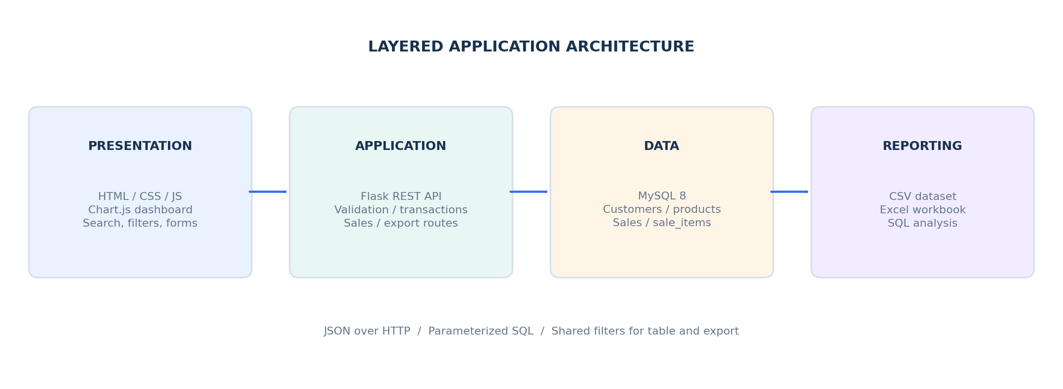
Figure 2.1: Application layers and the reporting path
Because the sales listing and the Excel export use matching search, date-range and category filter parameters, a user who exports a file always gets the rows they were just looking at.

2.7 Assumptions and Constraints
- The system is meant for one store and one user at a time, running locally.
- The setup is written for Windows with Python 3.14, MySQL 8.0.31 or later and PowerShell.
- A sale-form submission carries one product line, although the database can already hold several lines per order.
- There is no sign-in or role management, so the system should not be exposed to untrusted users as it stands.
- The sample data covers January to October 2026 only, so findings describe that period and are not forecasts.

CHAPTER 3. DESIGN FLOW / PROCESS

3.1 Relational Data Model
The schema keeps customer and product master data apart from order headers and individual order lines. A sale may contain several sale_items in the database even though the current entry form submits one product line at a time. Foreign keys connect each order to a customer and each line to a sale and a product [2]. Figure 3.1 shows the four tables and Table 3.1 lists their main fields.
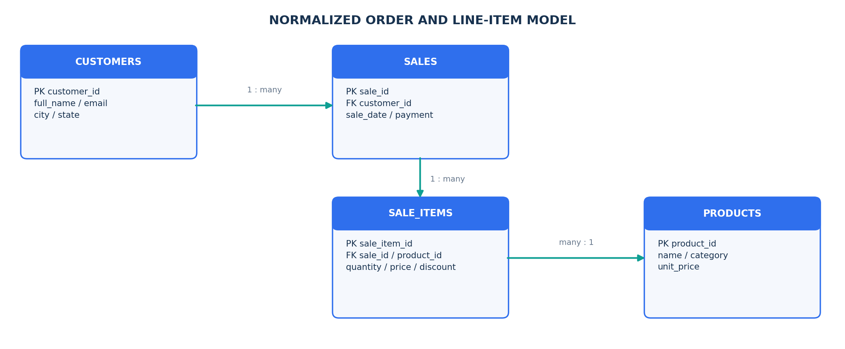
Figure 3.1: Core entity relationships and key fields (normalised order and line-item model)
Table 3.1: Main tables and their key fields
Table | Key fields | Role
customers | PK customer_id; full_name, email, city, state | Who bought; email is unique
products | PK product_id; name, category, unit_price | What is sold; name is unique
sales | PK sale_id; FK customer_id; sale_date, payment | One row per order (header)
sale_items | PK sale_item_id; FK sale_id, product_id; quantity, price, discount | One row per order line, with the price and discount at the time of sale

3.2 Integrity and Revenue Logic
- Customer email and product name are unique, and item quantity and unit price must be positive.
- The discount rate is constrained between 0 and 1, and a customer cannot be deleted while sales exist for them.
- Deleting a sale also deletes its sale-item rows, but a product that appears in any sale cannot be removed.
- Unit price and discount are stored on the order line, so the value agreed at purchase time never changes.
- Revenue is always calculated as quantity × sale-time unit price × (1 − discount rate).
As a simple illustration, if a customer buys 3 units of an item priced at INR 1,000 with a 10% discount, the line revenue is 3 × 1,000 × (1 − 0.10) = INR 2,700. Average order value is then total revenue divided by the number of distinct orders, so an order with several lines counts only once.

3.3 Request and Transaction Workflow
Recording a sale follows the same steps every time:
- The user fills in the sale form: customer, product, quantity, discount, payment method and date.
- The API validates every field. It does not accept a price from the browser.
- The API looks up the current unit price of the chosen product in the database [3].
- Inside one database transaction, it inserts the sale header and then its line item with the stored price and discount.
- If both inserts succeed, the transaction is committed and the new sale identifier is returned. If anything fails, the transaction is rolled back, so no half-saved order is left behind.

3.4 Shared Filters
The dashboard has one set of filters: a text search for customer or product, a from and to date, and a row of category boxes. Ticking any number of boxes narrows the data to those categories, and ticking none means all categories. The same parameters feed the KPI cards, both charts, the sales table and the Excel export, which is why every part of the page tells the same story. The export writes the filtered rows to sales_export.xlsx with a Total row at the bottom [1].

3.5 Data Processing
The report dataset is a CSV export from the v_sales_detail view, with one row per order line [4]. Aggregations group those rows by sale identifier, category, month or payment method as needed. The dashboard receives plain numeric values from the API, and the Excel workbook keeps line-level detail so that pivot tables and formulas can be added later.

3.6 Design Decisions and Alternatives
A few choices shaped the design more than any others. Table 3.2 sets each one beside the alternative that was considered and the reason it was not used.
Table 3.2: Design decisions and the alternatives considered
Decision | Chosen approach | Alternative | Reason
Source of price | Server reads it from the product table | Browser sends a price | Prevents wrong or tampered prices
Price history | Price and discount stored on each line | Use today’s catalogue price | Old sales keep their original value
Order structure | Header table plus line items | One flat sales table | Allows several lines per order later
Reporting | One shared filter set for all views | Separate filters per view | Numbers always agree
SQL access | Parameterised queries | Building SQL from text | Safer and easier to maintain

3.7 Module Overview
- Database module: schema.sql creates the tables, keys, indexes and constraints, and analysis.sql holds the SQL used to check the figures.
- API module: Flask routes for sales, customers, products, summaries, charts and export, with validation and transactions.
- Dashboard module: index.html and app.js draw the KPI cards, charts, filter bar, sales table and entry forms.
- Export module: builds the Excel workbook from the same filters, with line-level rows and a Total row.

CHAPTER 4. RESULTS ANALYSIS AND VALIDATION

4.1 Dataset Snapshot
The measures in Table 4.1 were recomputed directly from the 69-row CSV dataset.
Table 4.1: Dataset snapshot
Measure | Observed value
Order-line rows | 69
Distinct orders | 37
Units sold | 201
Total revenue | INR 159,188.00
Average order value | INR 4,302.38
Distinct customer / product names | 15 / 15
Dataset dates | 5 Jan – 21 Oct 2026

Some simple ratios put these numbers in perspective. There are about 1.9 order lines per order and about 5.4 units per order, and each unit brings in roughly INR 792 on average. The average revenue of a single order line is INR 2,307.07.

4.2 Category Performance
Figures 4.1 to 4.4 show the dashboard KPIs, the category comparison, the monthly movement and the payment mix of the dataset.
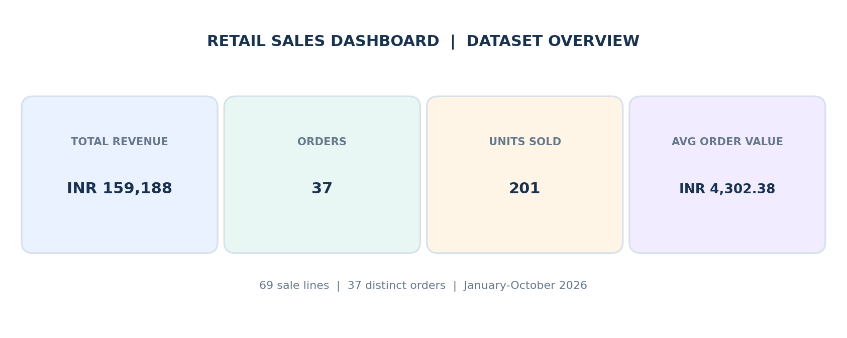  Figure 4.1: Dashboard KPI overview | 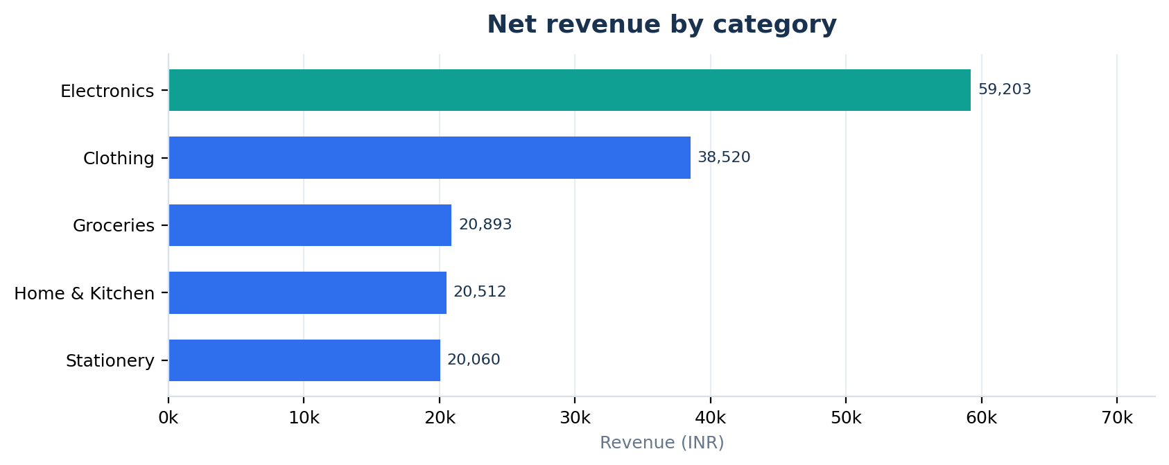  Figure 4.2: Revenue by category
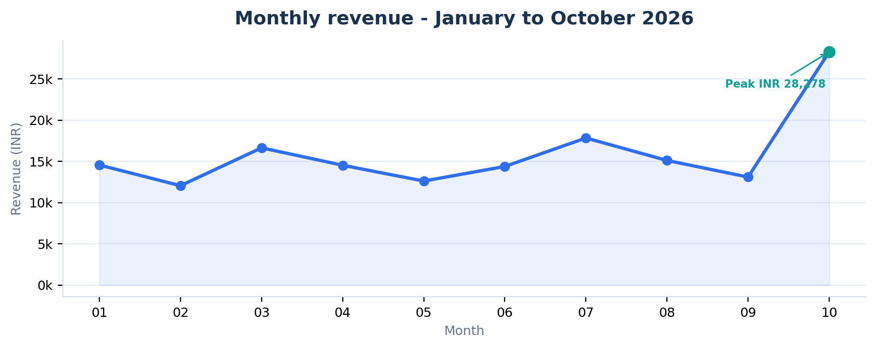  Figure 4.3: Monthly revenue trend | 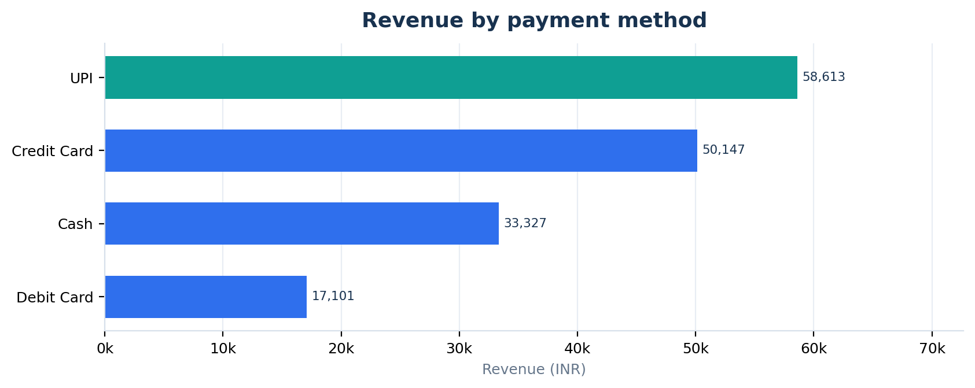  Figure 4.4: Revenue by payment method
Electronics leads the categories with INR 59,203.25, which is about 37% of all revenue, so no other category comes close to it in this sample. Clothing follows as the second-largest category, while Groceries, Home & Kitchen and Stationery sit at a similar, lower level.

4.3 Monthly Performance
Revenue stays fairly steady through the first nine months and then jumps sharply in October. February is the lowest month at INR 12,063.30 (about 7.6% of the total) and October is the strongest at INR 28,278.10 (about 17.8%), which is roughly 2.3 times the February figure (Figure 4.3). These findings describe a partial-year sample from January to October 2026, so they should be read as observations and not as a forecast.

4.4 Payment Mix and Outlier Context
UPI is the most used payment method, followed by credit card, cash and debit card. Table 4.2 gives the revenue and share for each.
Table 4.2: Payment method mix
Payment method | Revenue (INR) | Share of total
UPI | 58,612.95 | 36.8%
Credit Card | 50,147.10 | 31.5%
Cash | 33,326.65 | 20.9%
Debit Card | 17,101.30 | 10.7%
Total | 159,188.00 | 100%

Sale 37 is a documented, deliberate bulk order with quantities of 20 and 30 units and about INR 10,157.50 in revenue, which is around 6.4% of the whole dataset. It is worth remembering when looking at the late-year peak. The mean order-line revenue (INR 2,307.07) is higher than the median (INR 1,799.00), which is typical of a right-skewed distribution where a few large lines pull the average up.

4.5 Filtered View Example
Figure B.4 in the appendix shows what happens when the filters are used. With Clothing and Groceries ticked, the page shows 28 order lines, 16 orders and 63 units, with INR 59,412.55 in revenue and an average order value of INR 3,713.28. Every card, chart and table row changes together, and these numbers describe only that selection, not the full dataset in Table 4.1.

4.6 Requirement-wise Verification
Table 4.3 checks each requirement from Table 2.1 against what the project actually shows.
Table 4.3: Requirement-wise verification
ID | Requirement | Where it is shown
FR-01 | View sales KPIs and trends | KPI cards and charts (Figures 4.1 to 4.4, B.1)
FR-02 | Search and filter sales | Filtered dashboard with 28 lines (Figure B.4)
FR-03 | Export selected records | Downloaded sales_export workbook (Figure B.3)
FR-04 | Maintain basic records | Sale, customer and product forms (Figure B.2)
NFR-01 | Preserve transactional integrity | Foreign keys and the sale transaction (Section 3.3)
NFR-02 | Keep monetary history accurate | Sale-time price and discount on each line (Section 3.2)

4.7 Verification Record
Table 4.4 separates what was recomputed for this report from what is carried over from earlier project documentation, so that nothing is claimed twice.
Table 4.4: Verification evidence and status
Verification area | Evidence / status
Dataset totals | Recomputed from CSV: 69 lines, 37 orders, 201 units, INR 159,188.00
API / SQL agreement | Existing docs/report.md records matching totals across layers
End-to-end checks | Existing project report records 15 of 15 checks passing on clean seed data
Report scope | CSV metrics recalculated here; database and browser checks not rerun for this report

CHAPTER 5. CONCLUSION AND FUTURE WORK

5.1 Conclusion
The project delivers a complete small-retail reporting path: structured storage in MySQL, validated API operations in Flask, an interactive dashboard and a filtered Excel export. Its biggest strength is consistency. One revenue definition and one set of filters sit behind every number, so the rows, the metrics and the exported file always agree.
The analysis of the sample data shows what the system is meant to reveal: Electronics leads the categories, October is the strongest month, UPI is the most used payment method, and one deliberate bulk order has a visible effect on the totals. The figures were recomputed independently, and the limits of the evidence are stated openly in the verification record.

5.2 What the Project Taught
- Storing the price and discount on each order line is a small decision that protects the accuracy of every later report.
- Letting the server decide the price removes a whole class of data-entry mistakes.
- Sharing one set of filters across the cards, charts, table and export is what keeps a dashboard believable.
- Separating what was recomputed from what is inherited from older documents makes a report easier to trust.

5.3 Limitations
- There is no authentication, authorization or audit history, so the system suits a single local user only.
- Only one product line can be entered per sale-form submission, and there are no edit or cancel screens.
- The sample covers one store and ten months, with no inventory, cost or margin data.

5.4 Future Work
- Add sign-in, roles and audit history before it is used by more than one person.
- Support multi-item order entry and controlled edit and cancel workflows.
- Extend the sample with inventory, cost and margin, and a longer time range.
- Automate the repeatable data checks and regenerate the report from refreshed exports.
Recommendation: treat the included figures as an illustrative sample until access control, operational workflows and broader production data are in place.

REFERENCES
[1] Retail Sales Analytics project repository. README.md: system scope, setup, endpoints, and expected seed-data totals.
[2] Retail Sales Analytics project repository. database/schema.sql: MySQL tables, keys, indexes, and constraints.
[3] Retail Sales Analytics project repository. backend/routes/sales.py and backend/routes/export.py: sales API and filtered Excel export.
[4] Retail Sales Analytics project repository. data/sales_dataset.csv: 69-row report dataset used for this analysis.
[5] Flask documentation. [Online]. Available: https://flask.palletsprojects.com/
[6] MySQL 8.0 Reference Manual. [Online]. Available: https://dev.mysql.com/doc/refman/8.0/en/
[7] Chart.js documentation. [Online]. Available: https://www.chartjs.org/docs/latest/
[8] openpyxl documentation. [Online]. Available: https://openpyxl.readthedocs.io/
[9] Retail Sales Analytics source code repository. [Online]. Available: https://github.com/karmansingh880-collab/retail-sales-analytics

APPENDIX

A. Principal Project Files
Table A.1 lists the main files of the project and what each one does.
Table A.1: Principal project files and what they do
File | Purpose
backend/app.py | Starts the Flask application
backend/routes/ | API routes for sales, master data, summaries and Excel export
frontend/index.html | The dashboard page
frontend/js/app.js | Dashboard logic: filters, charts, table and forms
database/schema.sql | Tables, keys, indexes and constraints
database/analysis.sql | SQL used for analysis and cross-checking
data/sales_dataset.csv | The 69-row dataset used in this report
data/make_excel.py | Builds the Excel analysis workbook
docs/excel_guide.md | Guide to the Excel workbook
docs/e2e_check.ps1 | PowerShell end-to-end check script

B. Project Screenshots
These screenshots show the implemented interface and the export workflow. The first is the full sample dashboard, the second shows the entry forms, the third confirms that the Excel file was downloaded, and the fourth shows a filtered dashboard. The values in the filtered screenshot belong to that selection only and should not be compared with the full-dataset totals in Chapter 4.
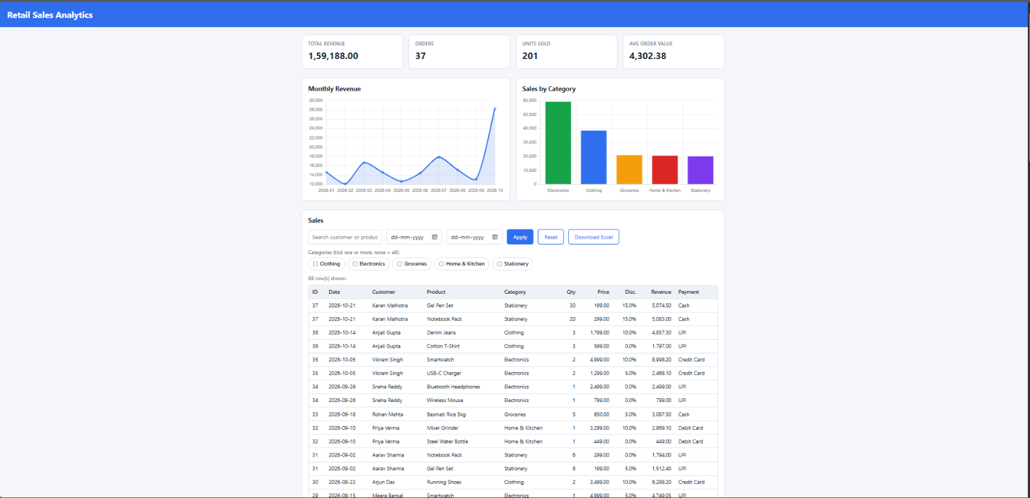
Figure B.1: Full dashboard: revenue, orders, units, average order value, charts and sales table
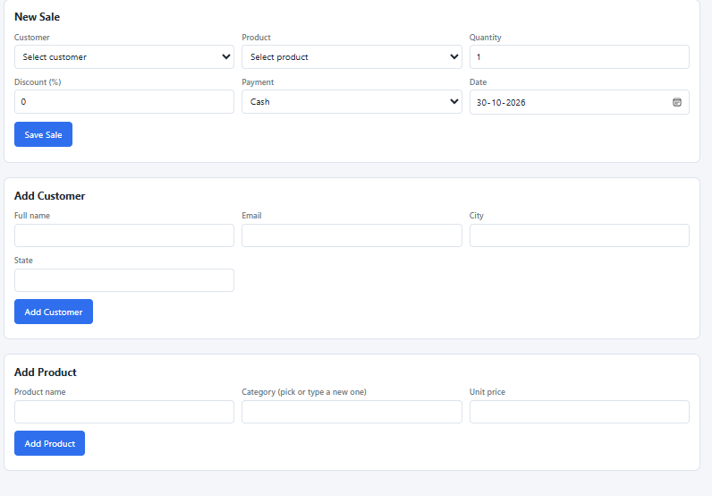
Figure B.2: Entry forms for a sale, customer and product; the sale price comes from the product record

Figure B.3: Browser Downloads confirms the generated sales_export Excel workbook
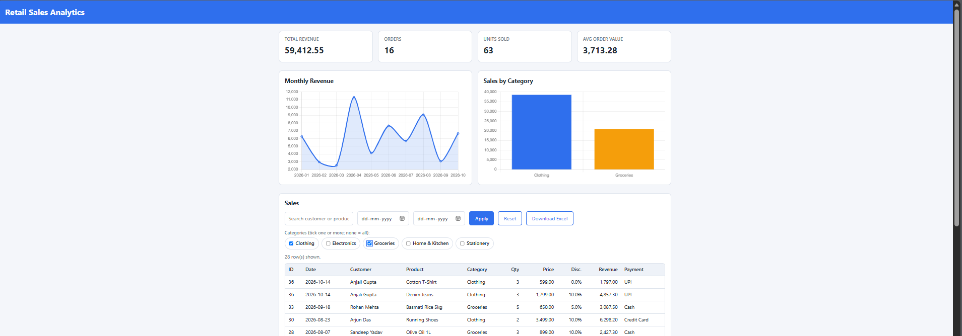
Figure B.4: Filtered example with Clothing and Groceries selected; its KPIs and 28 displayed lines are specific to that filter

USER MANUAL

Installation and Launch
Requirements: Windows, Python 3.14, MySQL 8.0.31 or later, and PowerShell.
- Install dependencies: pip install flask flask-cors pymysql openpyxl
- Load the database scripts: Get-Content database\schema.sql | mysql -u root -p, then load sample_data.sql into retail_sales.
- Set the credentials: put the retail_app MySQL credentials in the .env file that backend/config.py reads.
- Start the application: from the backend folder run python app.py, then open http://127.0.0.1:5000/ in a browser.
- Run the checks: powershell -ExecutionPolicy Bypass -File docs\e2e_check.ps1.

Using the Dashboard
- View KPIs and charts: revenue, orders, units sold and average order value are at the top, followed by the monthly revenue and sales-by-category charts.
- Filter sales: type a customer or product, pick a from and to date, tick one or more categories and press Apply. Reset clears everything.
- Export: press Download Excel to save the rows that match the current filters as sales_export.xlsx.

Recording Data
- New sale: choose the customer and product, enter the quantity and discount, pick the payment method and date, then press Save Sale. The price is taken from the product record.
- New customer: enter the name, email, city and state, then press Add Customer. Emails must be unique.
- New product: enter the name, pick or type a category and give the unit price, then press Add Product. Product names must be unique.

Troubleshooting
Table M.1 lists the problems most likely to come up during setup and the first thing to try.
Table M.1: Common problems and what to try
Problem | Likely cause | What to try
Page does not open at 127.0.0.1:5000 | The app is not running or the port is busy | Run python app.py again from the backend folder and read any error in the terminal
Database connection error | Wrong credentials or MySQL is stopped | Check the .env values and make sure the MySQL service is running
“Module not found” error | A dependency is missing | Run the pip install command again
Totals differ from the report | sample_data.sql not loaded or data was changed | Reload the schema and sample data into a clean database

PROJECT REPOSITORY
The complete source code of the Retail Sales Analytics System, including the backend, frontend, database scripts, dataset and documentation, is kept in the following GitHub repository [9]:
https://github.com/karmansingh880-collab/retail-sales-analytics.git
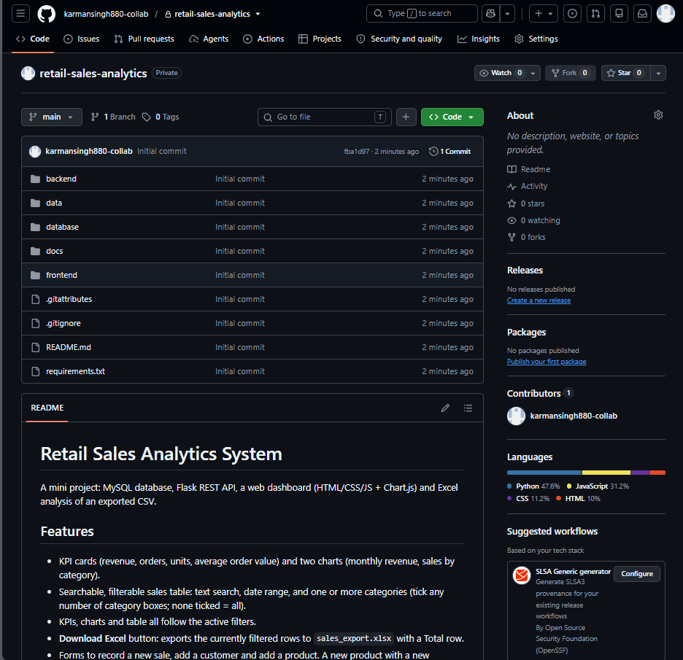
Figure C.1: GitHub repository “retail-sales-analytics” with the backend, data, database, docs and frontend folders and the project README

